A

PROJECT REPORT

ON

**“T-Kart E-Commerce Website”**

Submitted to

MSBTE, MAHARASHTRA

In the partial fulfilment of the degree of

DIPLOMA IN COMPUTER ENGINEERING

BY

**Mr. Mohammad Sami Shaikh**

**Mr. Karthik Devadiga**

**Mr. Akhilesh Bamane**

**Guidance by Mr. M.P. Jamdar**



PADMABHOOSHAN VASANTRAODADA PATIL

INSTITUTE OF TECHNOLOGY, BUDHGAON,

SANGLI

2020-2021



PADMABHOOSHAN VASANTRAODADA PATIL

INSTITUTE OF TECHNOLOGY, BUDHGAON, SANGLI

**Certificate**

This is to certify that the project entitled “T-Kart E-commerce Website” Submitted by Mr. Karthik Devadiga, Mr. Mohammad Sami Shaikh and Mr. Akhilesh Bamane. In partial fulfilment of the requirement of the award of **DIPLOMA IN COMPUTER ENGINEERING TO MSBTE, MAHARASHTRA** Mumbai has been carried out by him our guidance, as an internal guide, satisfactorily during the academic year 2020-2021

Place: Sangli

Date:

**Mr. M.P Jamdar Mr. S.B Shendage**

Project Guide H.O.D

Examiner **Prof B.B Patil**

Principal

**Acknowledgement**

Every orientation work has an imprint of many people and it becomes our duty to express deep gratitude for the same. During the entire duration of preparation for this Dissertation, we received endless help from a number of people and feel that this report would be incomplete if we do not convey graceful thanks to them.

This acknowledgement is hummable attempt to thanks all those who were involved in the project work and were of immense help to us. First and foremost we take the opportunity to extend our deep heartfelt gratitude to our project guide **Mr. M.P. Jamdar** for guiding us throughout the entire project and for his kind and valuable suggestions, without which this idea won’t have executed. I also humbly thanks to **Prof. S.B. Shendage, Head of Department of Computer Engineering, P.V.P.I.T. Budhgaon (Sangli)**, for his indispensable support, his priceless suggestion and for his teaching and non-teaching staff for their advice and kind cooperation.

We also thanks our parents and all my colleagues for encouraging me with their valuable suggestions and motivating me from time to time. Finally, last but not least, we would thank the almighty without whose care and blessing this work would have not completed.

**ABSTRACT**

The purpose of the project entitled “T-Kart E-Commerce Website” is to computerize the Front end a Management of an online e-commerce store to develop software that is user-friendly simple, fast and cost-effective, for personal use and makes the data processing very fast. Shopping Cart System is a Simple shopping Solution. It’s a full-featured website and shopping cart system that bends over backwards to give us the flexibility we need to run our online bag store. The basic concept of the application is to allow the customer to shop virtually using the Internet and allow customers to buy the bags of their desire from the store. The information pertaining to the products are stored on an USA Database Server. The Server processes the customers and the items are shipped to the address submitted by them. The details of the items are brought forward from the database for the customer view based on the selection through the menu and the database of all the products are updated at the end of each transaction.

Electronic Commerce is process of doing business through computer networks. A person sitting on his chair in front of a computer can access all the facilities of the Internet to buy or sell the products.

Unlike traditional commerce that is carried out physically with effort of a person to go & get products, ecommerce has made it easier for human to reduce physical work and to save time.    E-Commerce which was started in early 1990’s has taken a great leap in the world of computers, but the fact that has hindered the growth of e-commerce is security. Security is the challenge facing e-commerce today & there is still a lot of advancement made in the field of security.

The main advantage of e-commerce over traditional commerce is the user can browse online shops, compare prices and order merchandise sitting at home on their PC.

For increasing the use of e-commerce in developing countries the B2B e-commerce is implemented for improving access to global markets for firms in developing countries. For a developing country advancement in the field of e-commerce is essential. The research strategy shows the importance of the e-commerce in developing countries for business applications.

**Definition of E-commerce**

Electronic commerce or ecommerce is a term for any type of business, or commercial transaction, that involves the transfer of information across the Internet. It covers a range of different types of businesses, from consumer-based retail sites, through auction or music sites, to business exchanges trading goods and services between corporations. It is currently one of the most important aspects of the Internet to emerge.

**INDEX**

1. **Introduction…………………………………….……**
   1. Need…………………………………………
   2. Problem Definition………………………….
   3. Scope……………………………………….
   4. Goals and Objectives……………………….
2. **Software Requirement Specification………**…………
   1. Introduction…………………………………
   2. Purpose and Scope of Documents………….
   3. Functional and non-Functional

Requirement……………………………………….

1. **System Design………………………………………….**
   1. Data Flow Diagram level 0…………………
   2. Data Flow Diagram level 1…………………
   3. Data Flow Diagram level 2…………………
   4. Use Case Diagram…………………………..
   5. Architecture Diagram……………………….
   6. Sequence Diagram………………………….
   7. Activity Diagram -1…………………………
   8. Activity Diagram -2…………………………
   9. State Transition Diagram……………………
   10. E-R Diagram……………………………….
2. **Implementation Details………………………….**
3. **Technical Specification………………………….**
4. **Project Management Plan………………………**
5. **Software Testing…………………………………….**
6. **Experimental Details……………………………..**
7. **Conclusion and Future Work………………..**

**List of Figure’s and Tables**

1. List of Figures

List Tables

|  |  |  |
| --- | --- | --- |
| Figure No | Name | Page No |
| 1 | DFD Level 0 | 13 |
| 2 | DFD Level 1 | 13 |
| 3 | DFD Level 2 | 14 |
| 4 | Architecture Diagram | 15 |
| 5 | Sequence Diagram | 16 |
| 6 | Use Case Diagram | 16 |
| 7 | Activity Diagram -1 | 17 |
| 8 | Activity Diagram -2 | 17 |
| 9 | State Transition Diagram | 18 |
| 10 | E-R Diagram | 18 |

**Introduction**

The project of  **E-Commerce Website** has been developed on Python (Django), HTM, CSS, JavaScript, and SQLite Database. An online bag shopping store which will allow formal and informal merchants in developing countries to advertise and sell their good on the internet. This would permit rural communities to make their wares available to the rest of the world via the World Wide Web. The objective of this project is to create an e-commerce web portal with a content management system which would allow product information to be updated securely using a mobile device. The web portal will have an online interface in the form of an e-commerce website that will allow users to buy goods from the merchants. I have used Python for business logic, SQLite as a database, HTML for structure designing, CSS for web page formatting, JavaScript for form validation and animation..

**Need:**

* A domain Name.
* A web hosting provider.
* An integrated payment processor.
* A platform or tool to build your store.
* Initial capital to create your products
* Packaging for product shipping.

Electronic **commerce** or **e**-**commerce** (sometimes written as **eCommerce**) is a business model that lets firms and individuals buy and sell things over the internet. **E**-**commerce** operates in all four of the following major market segments: Business to business. Business to consumer

**Problem Definition:**

When users land on an **e**-**commerce site**, they expect to find what they are looking for quickly and easily. ... Also, users are not sure about the brands or the actual products they want to purchase. They have a very broad idea about what they want to buy.

**Scope:**

The Project is developed as a desktop application. But later on the project can be modified to operate it online. In this project we can also add some new introduced security techniques for improving the more security. Sometimes due to irregular fingerprints problem while detection may occurs. so we can use fingerprint sensor with high accuracy. Also security of system can be improved by encryption methods. In this project we can also add the acknowledgement filed for voter to know him/her there vote was successfully added. We can also use the some newly introduced modern techniques for better performance and security.

**Goals and Objectives:**

1. Find the best solution for their needs
2. Make a purchase, and
3. Get information/answers to their questions
4. Quick way and easy way.
5. **Online** payment.
6. No need to approach others for getting details.
7. No need of doing manual work.

**Software Requirement Specifications**

**Introduction**

E-Commerce, also known as e-Business, or electronic business, is simply the sale and purchase of services and goods over an electronic medium, like the Internet.

It also involves electronically transferring data and funds between two or more parties. Simply put, it is online shopping as we commonly know it.

E-Commerce started way back in the 1960s when organizations began to use Electronic Data Interchange (EDI) to transfer documents of their business back and forth. The 1990s saw the emergence of online shopping businesses, which is quite a phenomenon today. The first-ever online purchase was a Sting CD, sold by US retailer, Net Market on 11 August 1994.

It has become so convenient and easy, that anyone can shop for anything right from a living room, with just a few clicks.

This has evolved more with the emergence of smartphones, where now, you can shop from anywhere and anytime, with a wireless device connected to the Internet.

Now you can search for almost any product or service online, without having to go anywhere physically.

“In the next three years, eCommerce sales are expected to account for 15.5 percent of retail sales worldwide.”- Oberlo.in

**Objectives of Proposed System:**

* Faster buying process.
* Store and product listing creation.
* Cost reduction.
* Affordable advertising and marketing.
* Flexibility for customers.
* No reach limitations.
* Product and price comparison.
* Faster response to buyer/market demands.

**Purpose and scope of document**

**Purpose:**

There are plenty of purposes of a website, most of which can be confined to one goal, earning profits. An ecommerce website implies a virtual store where visitors come to the store, pick the products of choice, and become customers by purchasing them. Individuals earlier visited the brick the mortar store that was promising and trustworthy, inclining more towards major brands. However, the online ecommerce business has opened doors to businesses of all kinds. All businesses can now sell online with the right use of the resource.

The first step to grab a visitor’s attention is to create a beautiful website. You must invest your time in genuine market research and in building a creative ecommerce website. If you are not technically armed, you can consider using ecommerce platforms such as Wix, Nicepage that can do the job for you. It is a completely customizable, do-it-yourself platform that provides you with ready-to-use templates and themes to design your store without being a technical expert. Moreover, you can create a mobile app with distinct design, manage your selling platforms, and focus on marketing, all from one dashboard.

The more you focus on your ecommerce website, the higher will be your revenue as well as profit generation. The earlier you enhance your conversion rates, the more you’ll be able to benefit from your ecommerce website. As an online seller you might already know that with the help of an ecommerce website, you can sell physical as well as virtual products. If you were selling in a brick-and-mortar store, you have the option to show different products to your visitors, explain them the features, help them compare products, and sell the products directly. However, in the case of online ecommerce, how do you plan to make your products reach the right customers? Here’s when an ecommerce website comes handy. A sharp ecommerce website designing can help your products get the views of the right viewers that can potentially convert into your loyal customers.

An ecommerce website helps in reaching such remote customers which otherwise would not even know the existence of your physical store. You can say the world becomes your audience with an ecommerce website. All you have to do is create a stunning ecommerce website and market it using the right strategies (including organic ways, paid advertisements, marketing campaigns). We have listed down a few points that dictate the purpose of ecommerce websites:

1. The online sellers can get a wide range of customers from around the globe.
2. can get feedback for your services to improvise and boost your services.
3. The seller and the consumer can interact with each other regarding the products or services.
4. The consumers can get the details of the product you sell and your brand story (if you have invested your time in marketing).
5. It saves considerable time for the consumers; no endless walking to find products, no waiting in traffic jams, no hanging outside the trial rooms, and no waiting for billing.
6. Consumers can purchase online from anywhere at any time using your ecommerce website.
7. Websites help in marketing the products with detailed product descriptions, high-quality product images and videos, rich content, and sleek designing.
8. The right use of SEO and content can help in scoring the Search Engine Results Page (SERP).
9. With the use of cookies, you can collect consumer data including the demographics that can be used for target marketing.
10. You can add unlimited products to your ecommerce website and categorize them to sell efficiently.
11. An ecommerce website can be responsive to provide customer convenience.
12. You can include live chats, messages, and provide other contact details of your business on the ecommerce website.
13. Including a feedback form can help you get direct feedback from your customers.
14. A good website design along with strong content can help you build online traffic to boost sales.
15. A website can help you in creating brand authenticity and consumer trust.

**Scope of documents:**

All transactions would be handled electronically or online – **e-commerce** facilitates all the various shopping-related activities, including the purchase and sales of goods and services, shipping, billing, etc. online.

**Functional and Non-Functional Requirements**

**Functional Requirements**

**Minimum Hardware Requirements:**

* Processor : Intel Dual Core and above
* RAM : 2GB
* Hard Disk : 10GB
* Device : Computer, Laptop, Mobile

**Minimum Software Requirements:**

* Operating System : Mac OS, Windows 7 and above, Android, IOS
* Language : HTML, CSS, JS, PYTHON.
* Database : SQLite Server Database
* Tools : Visual Studio 2021, Heroku, GitHub

**Non-Functional Requirements**

**User Privacy:**

Our project is confined with policy of secure login. In this the user personal data related to the Account is successfully secured. The Password is Secure with SHA256 encryption algorithm

**User Friendly:**

**Dig starts from here……………….**

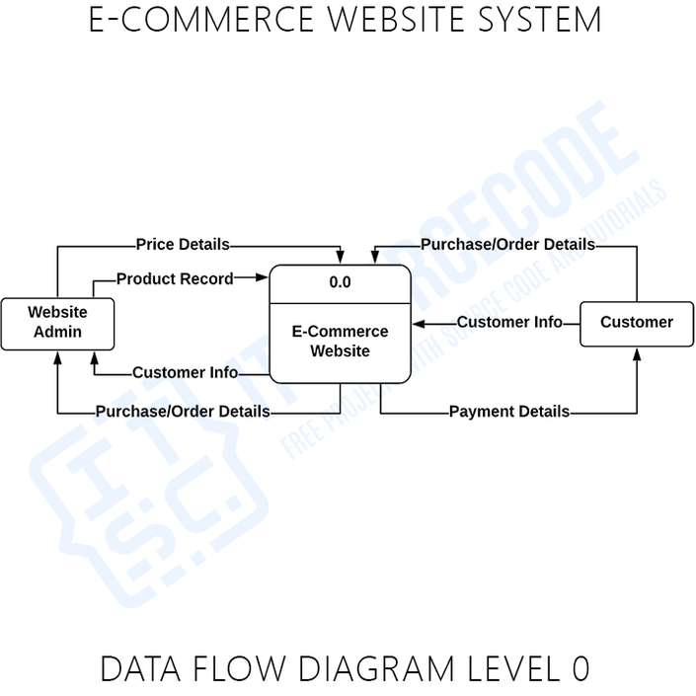

Diagram : 1 DFD Level 0

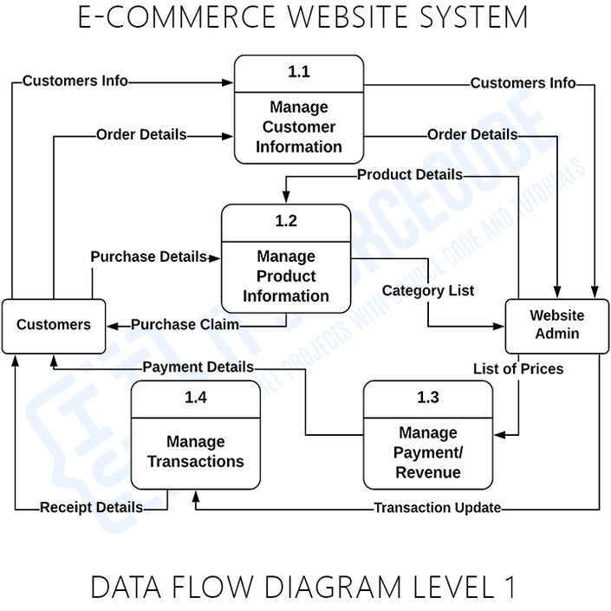

Diagram : 2 DFD Level 1

Diagram : 2 DFD Level 1

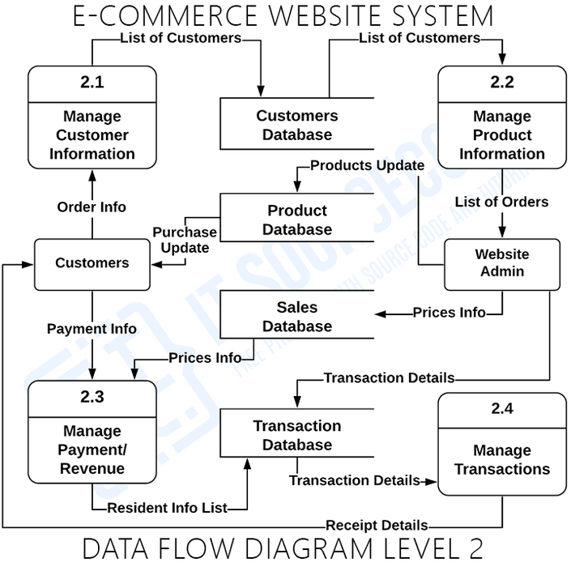

Diagram : 3 DFD Level 2



Diagram : 4 Architecture Diagram

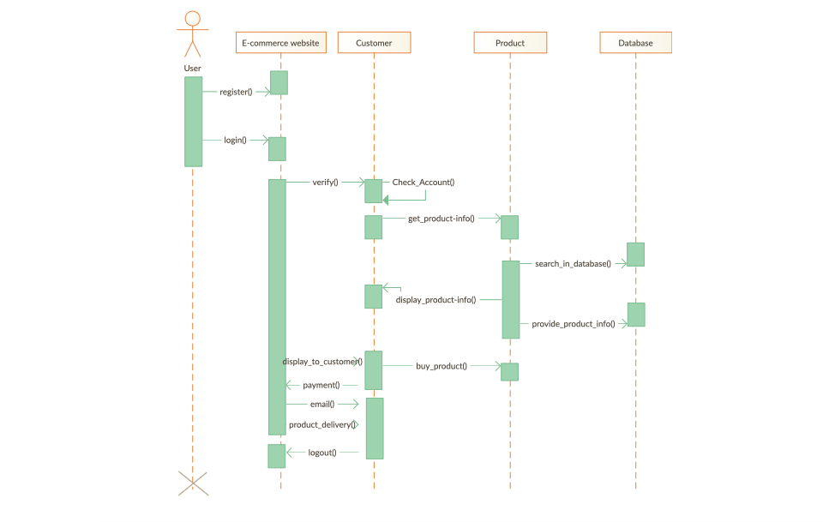

Diagram : 5 Sequence Diagram

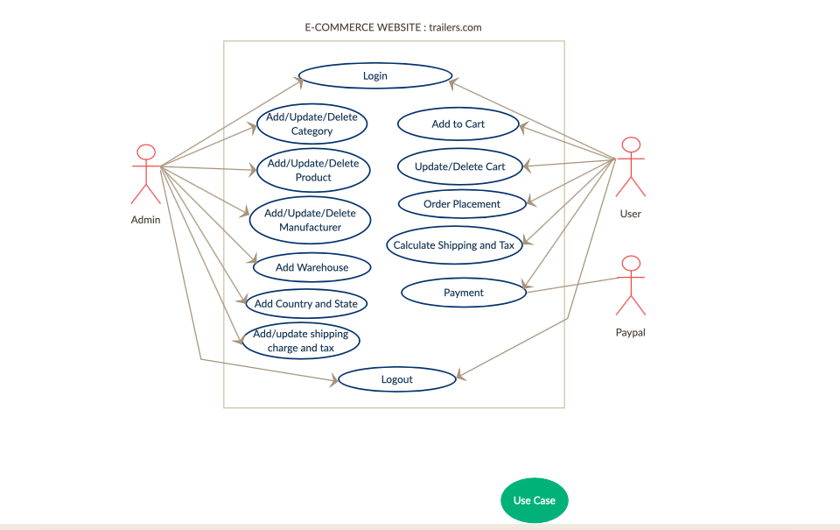

Diagram : 6 Use case Diagram

Activity Diagram Website :

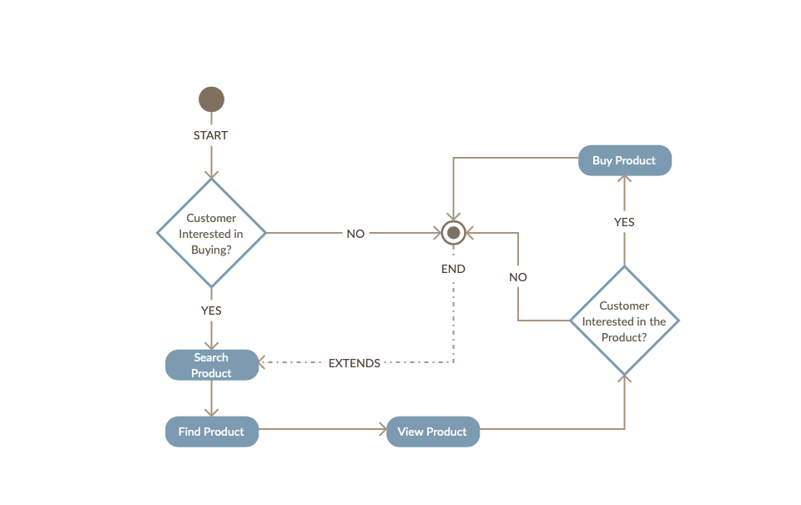

Diagram : 7 Activity Diagram-1

Activity Diagram Oder :

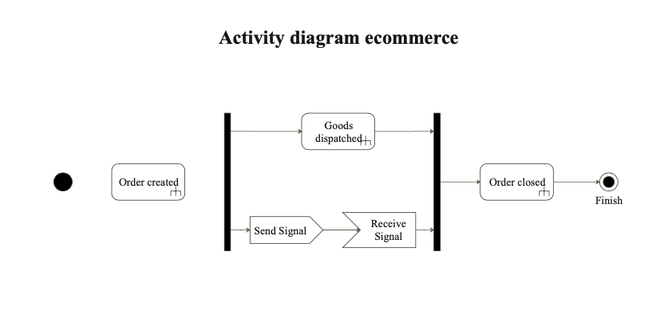

Diagram : 8 Activity Diagram-2

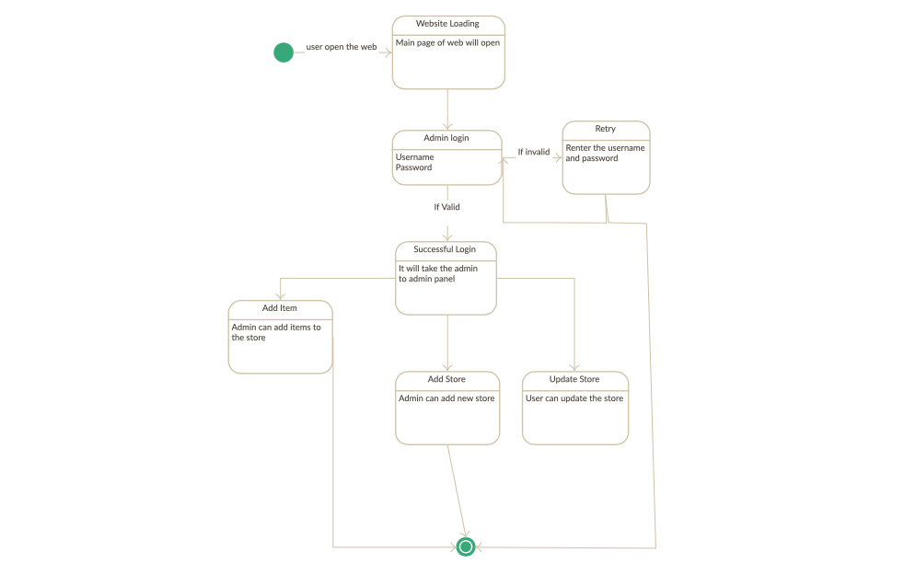

Diagram : 9 State Transition Diagram

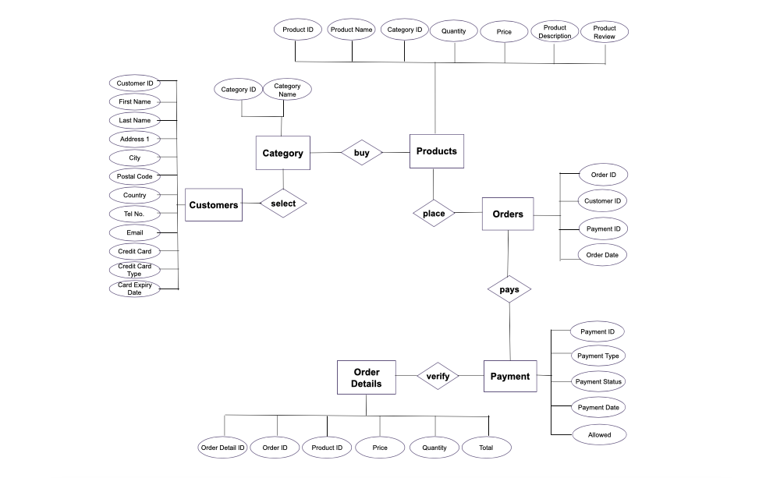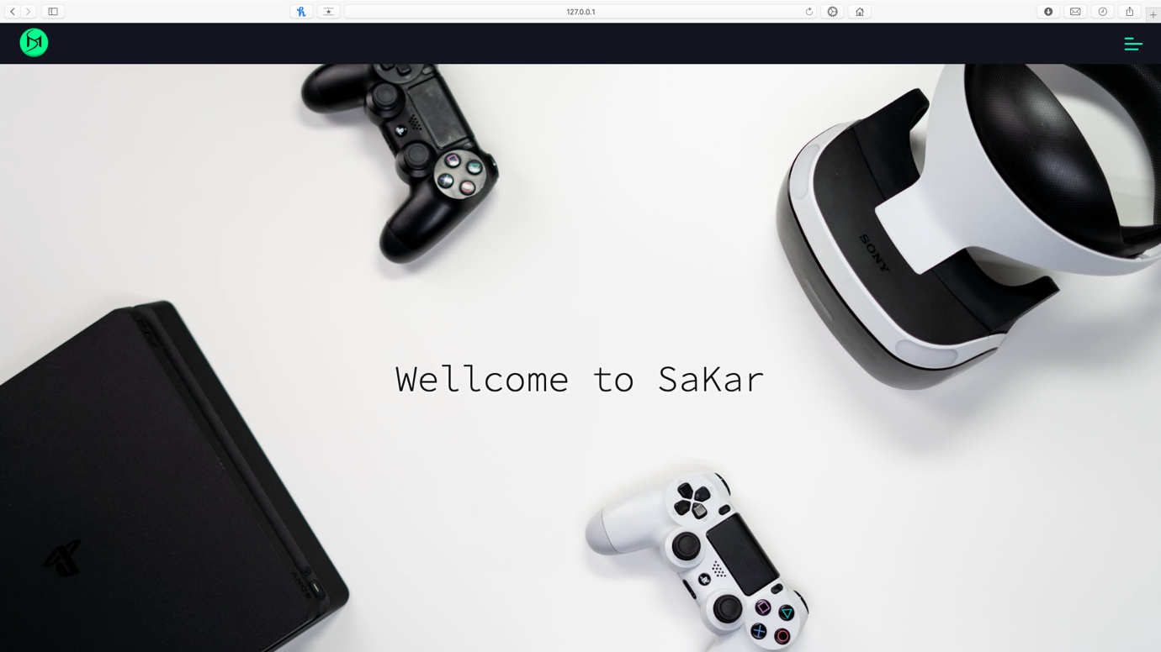

Diagram : 10 E-R Diagram

Home Page .fig1

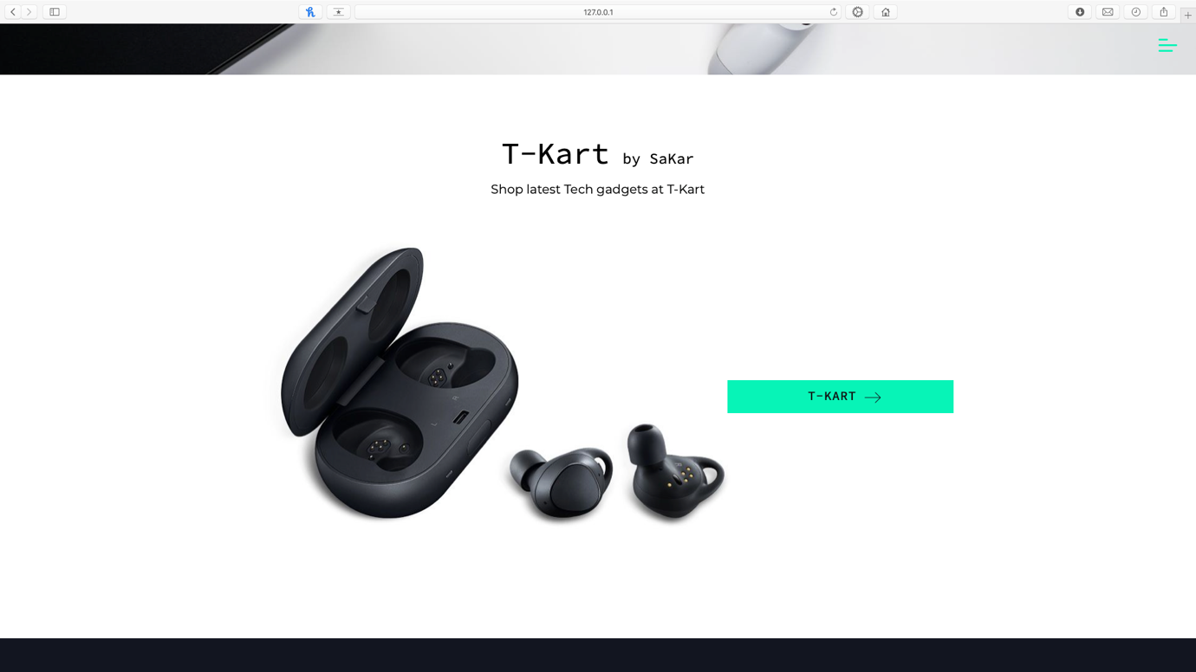

Home Page .fig2

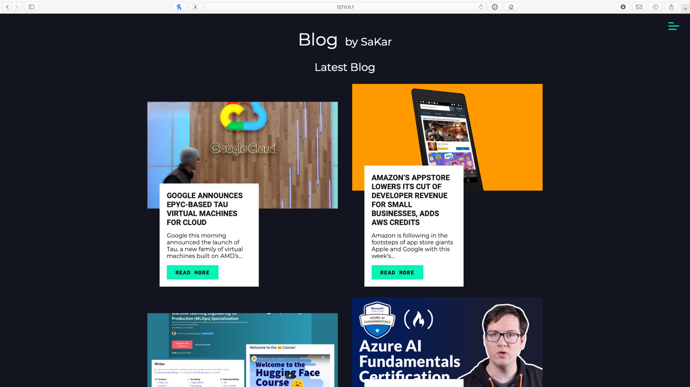

Home Page .fig3

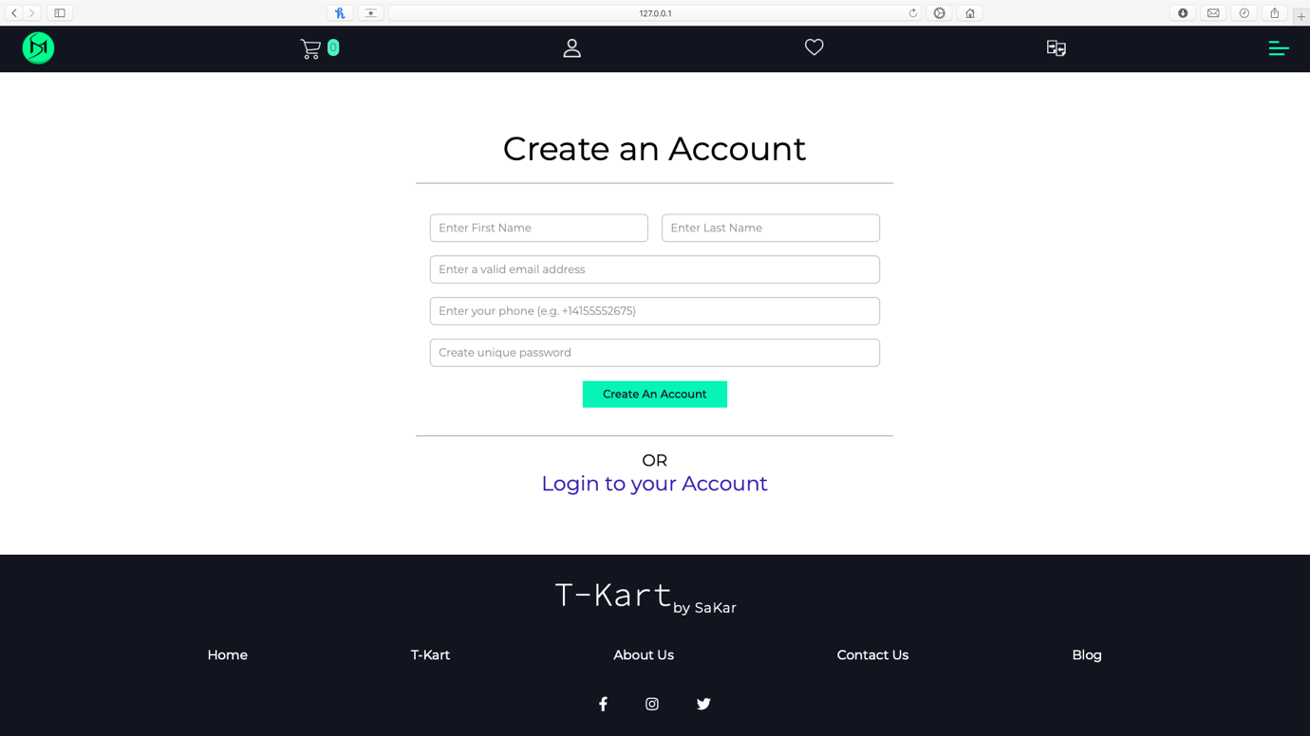

Sign Up Page 

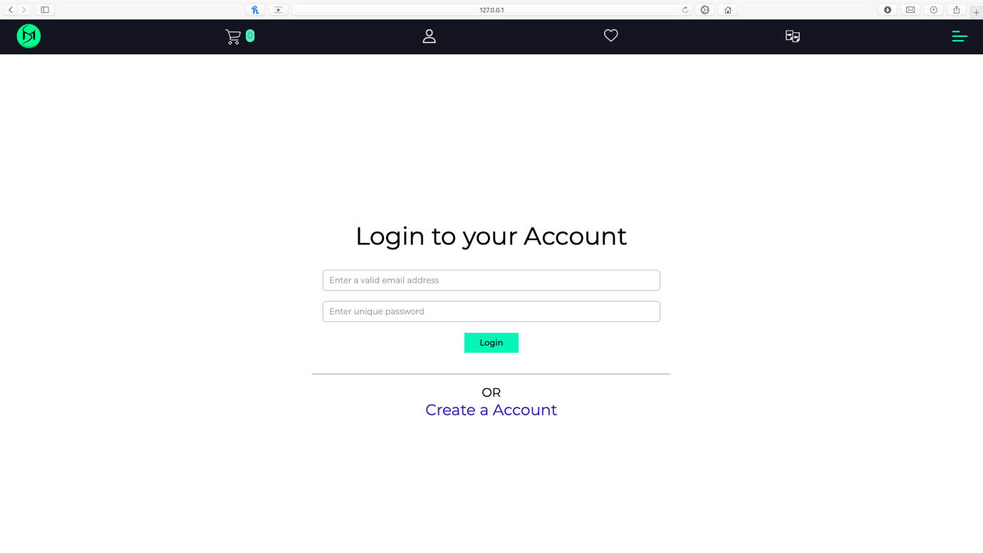

Login Page 

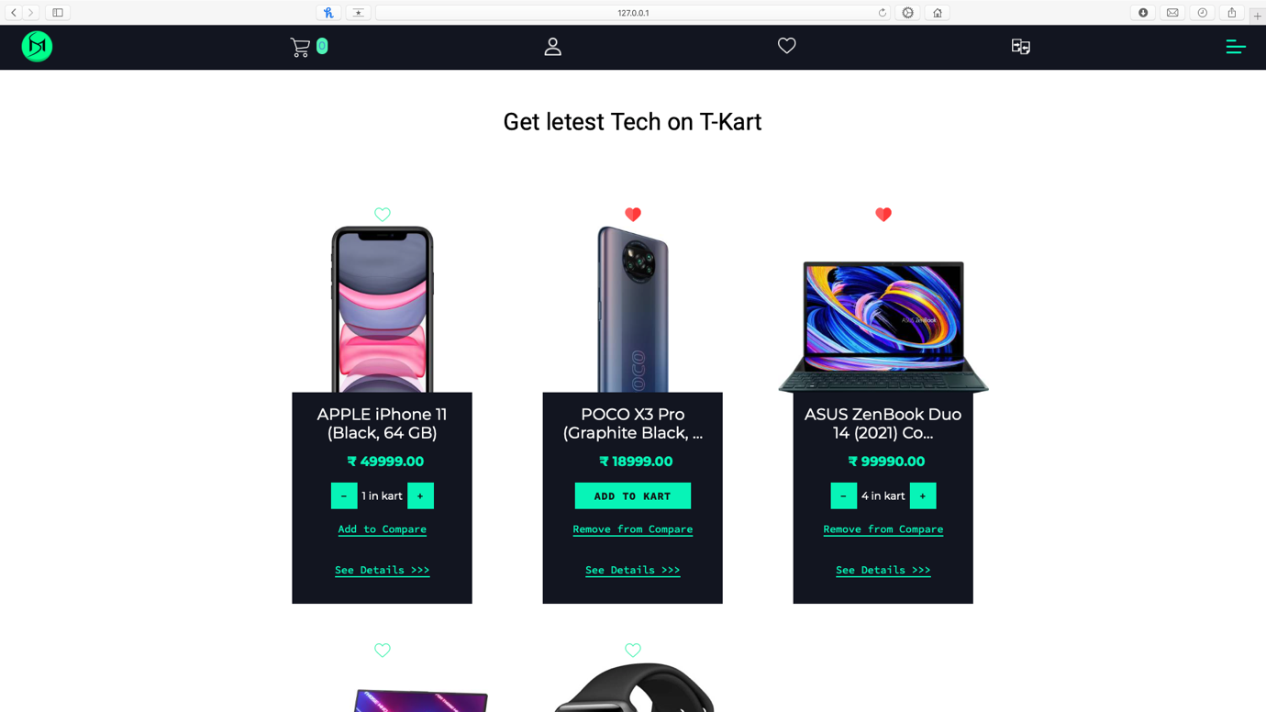

Shop Page .fig1

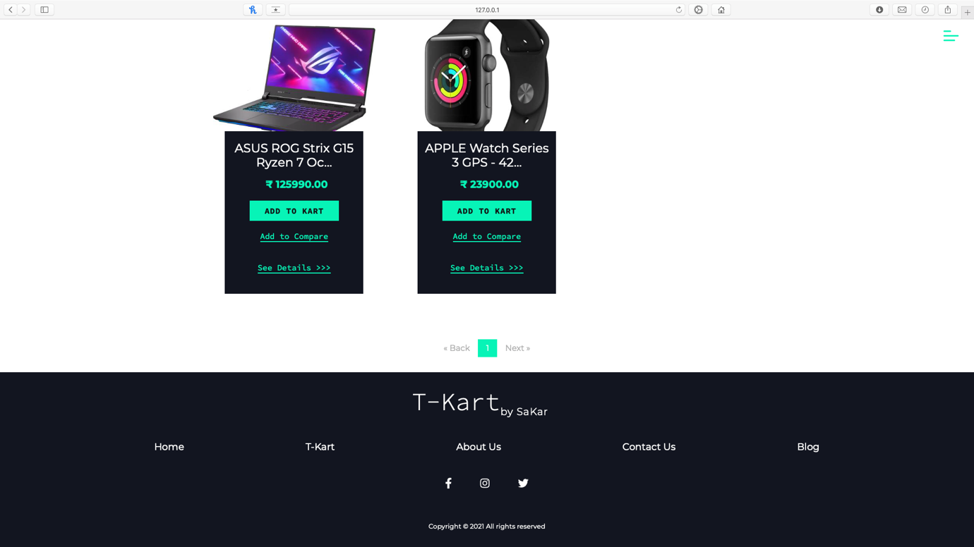

Shop Page .fig2

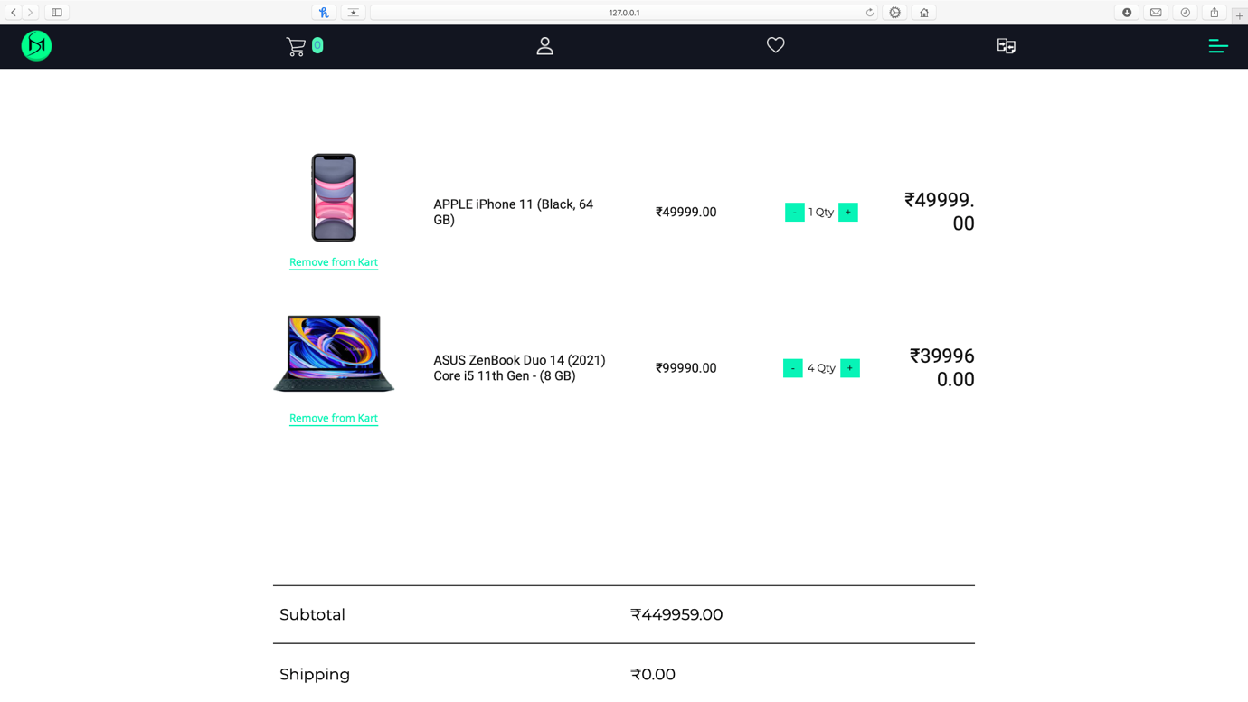

Cart Page .fig1

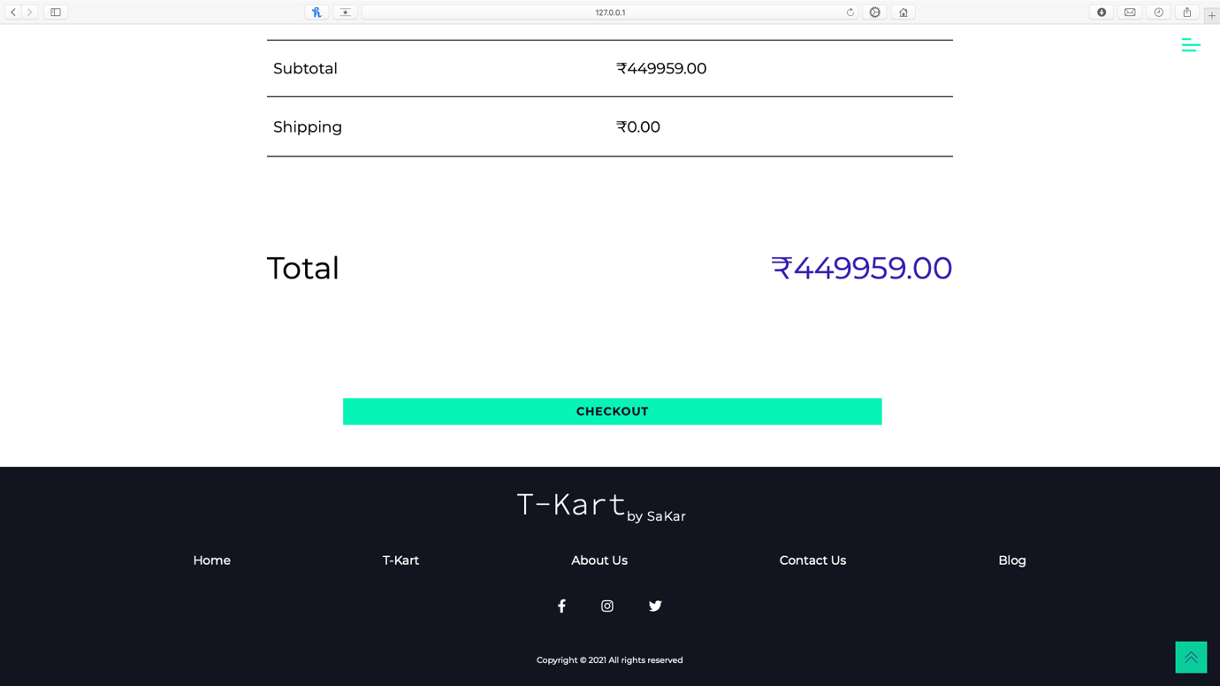

Cart Page .fig2

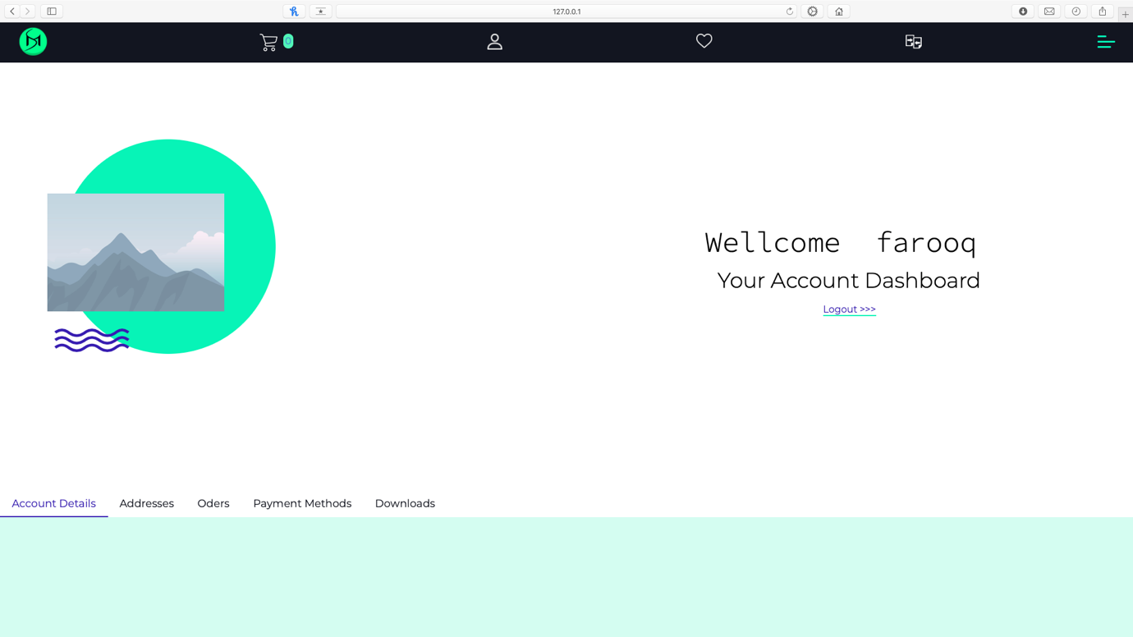

Account Page .fig1

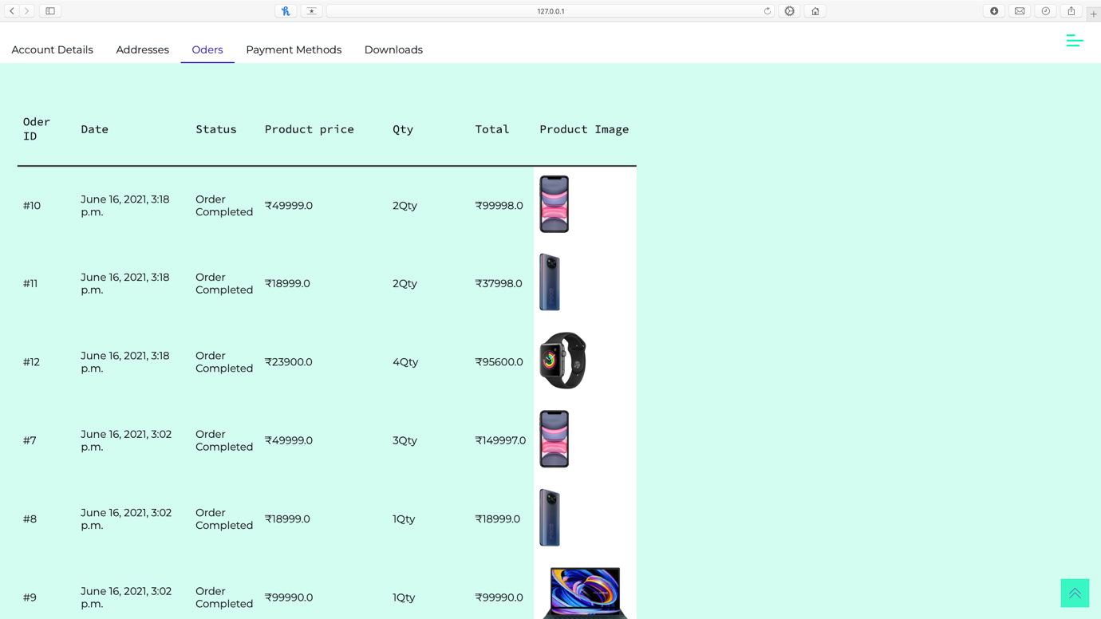

Account(orders) Page .fig2

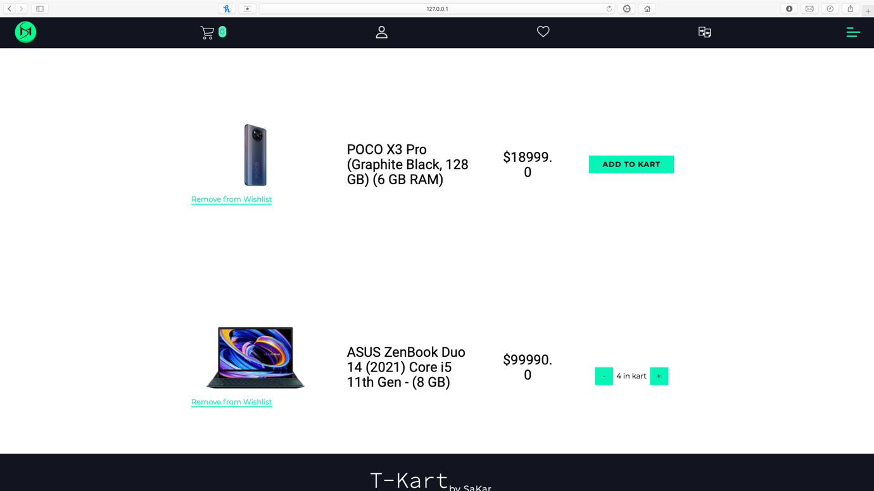

Wishlist Page 

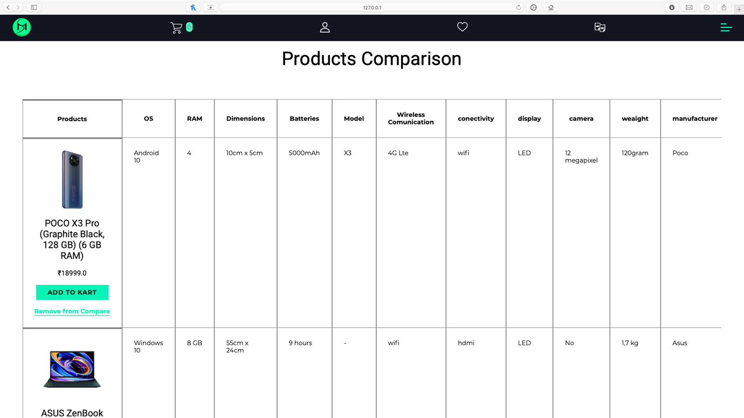

Comparison Page 

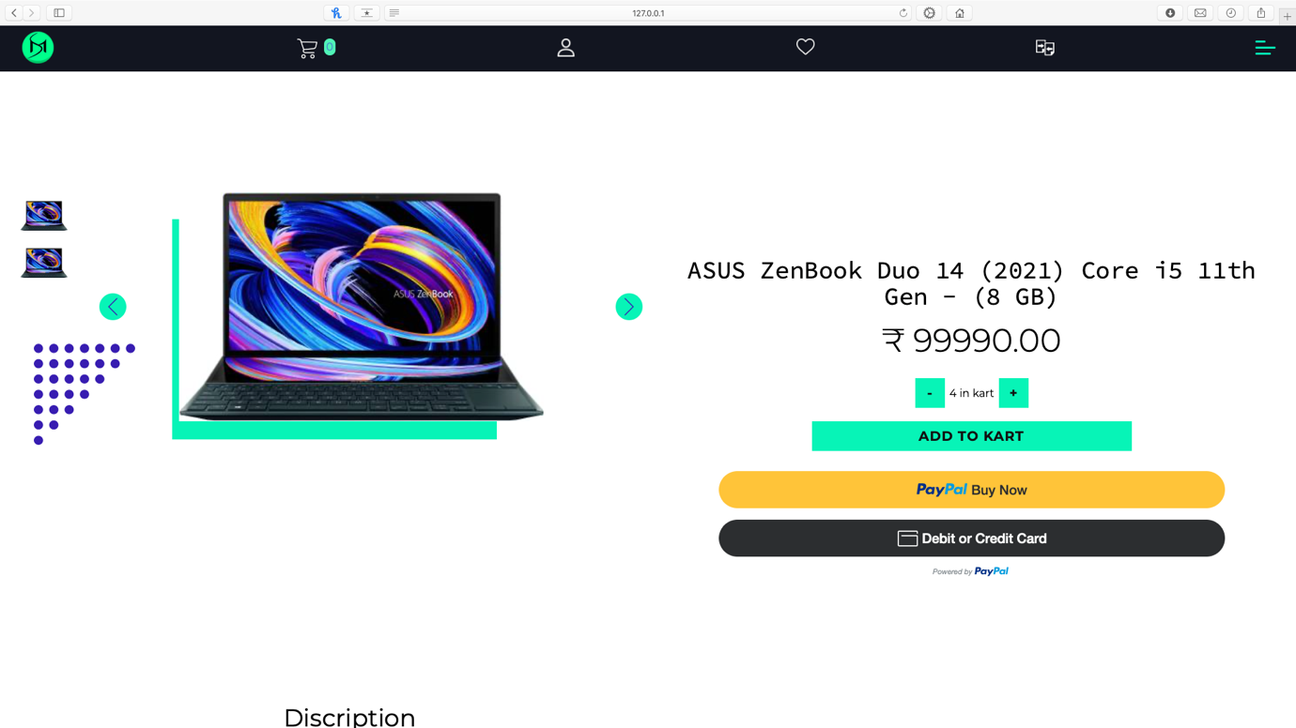

Product Page 

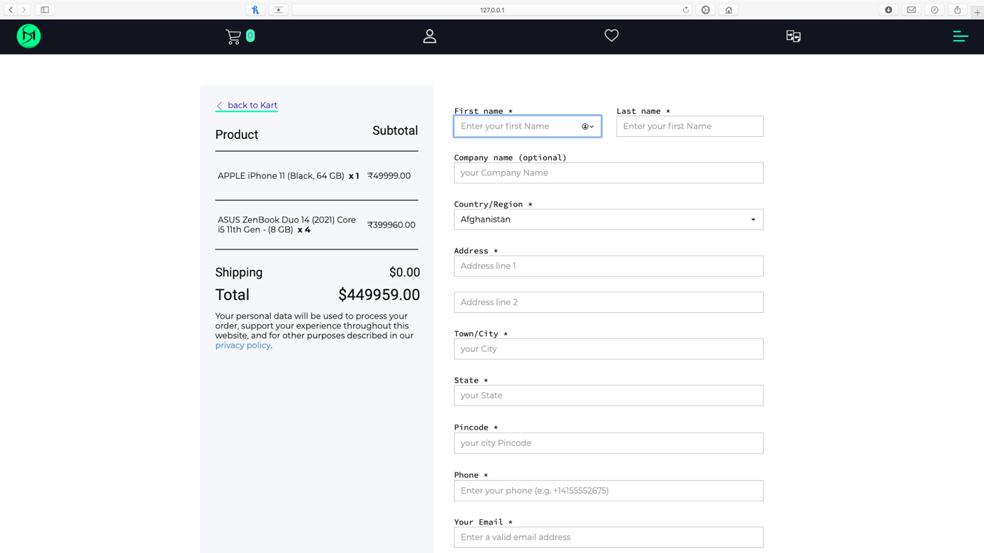

Checkout Page .fig1 

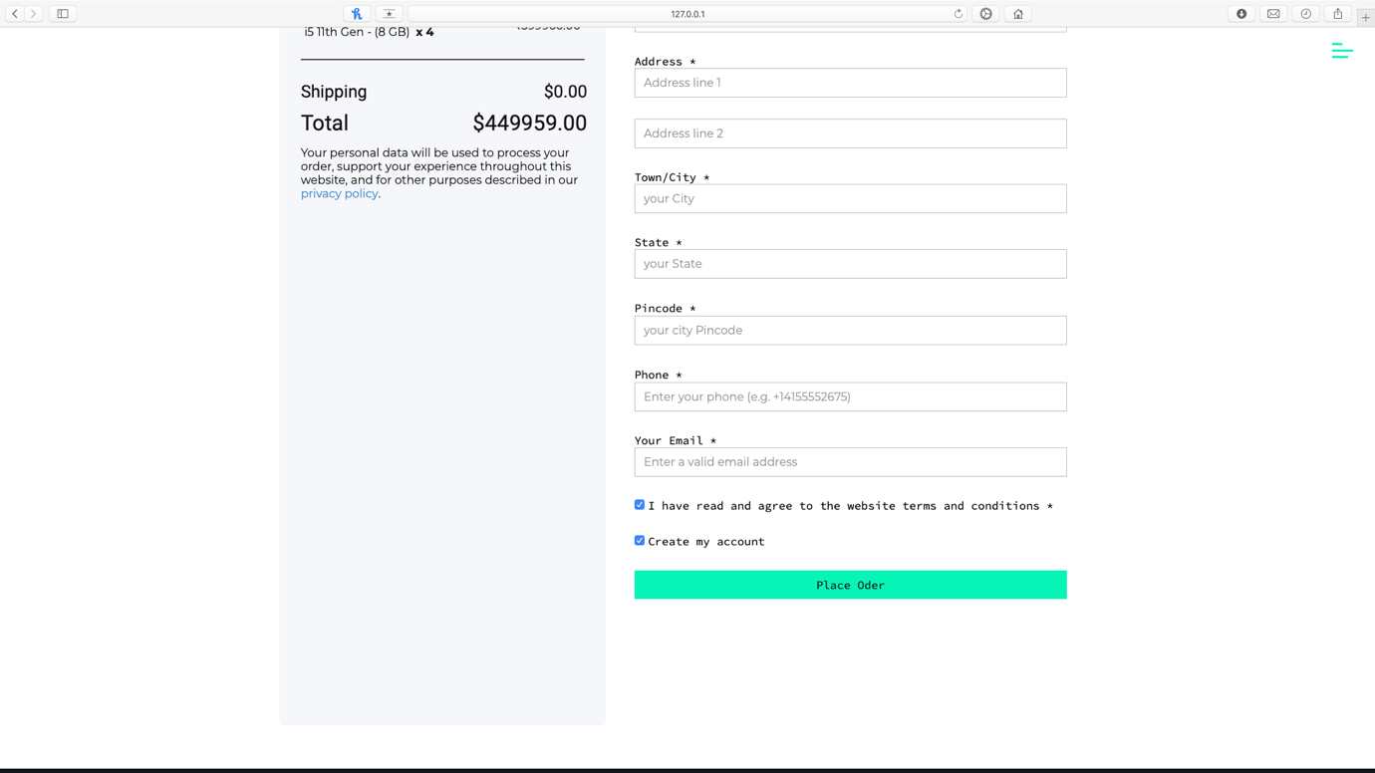

Checkout Page .fig2

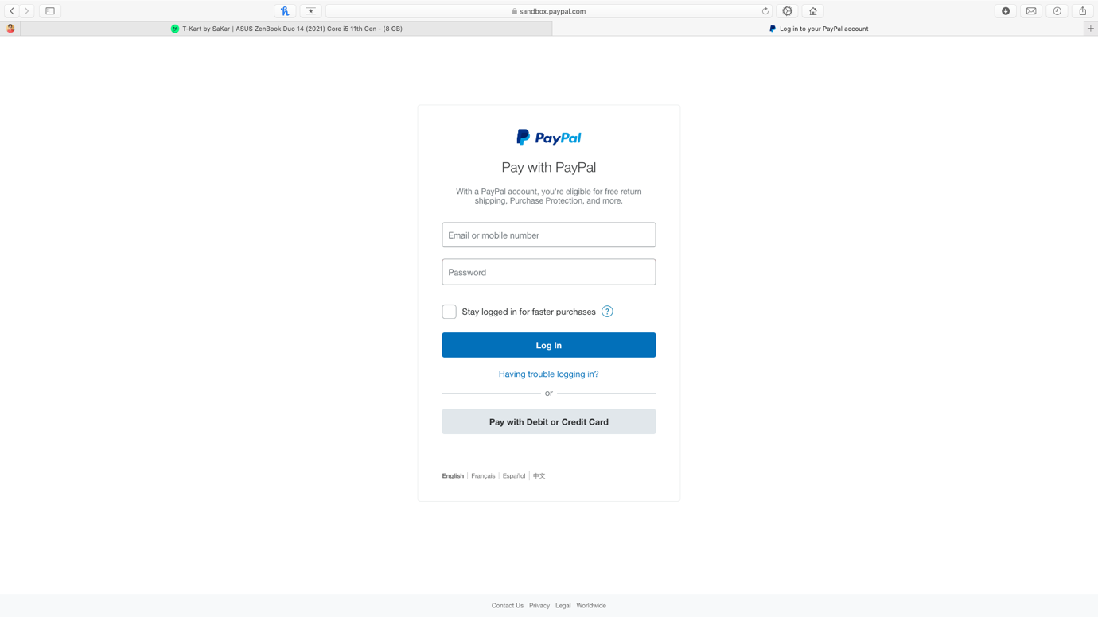

Payment(PayPal) Page 

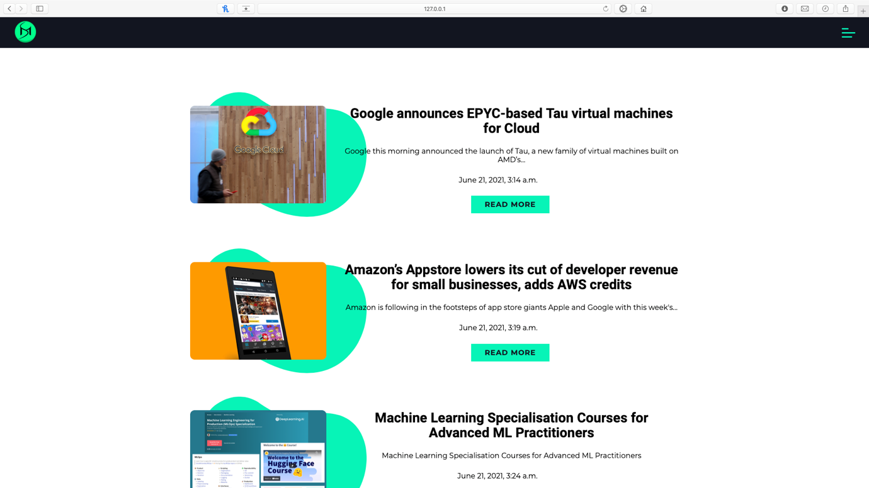

Blog Page 

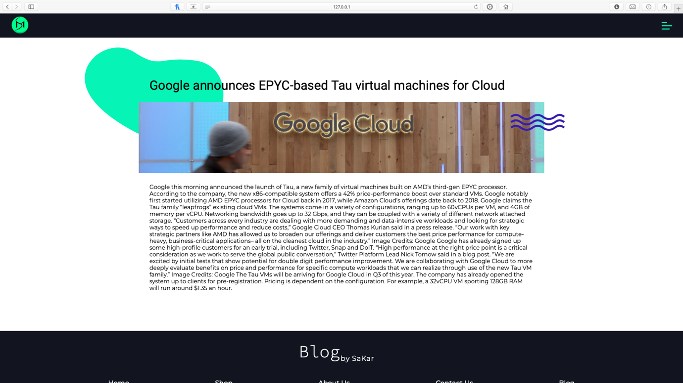

Blog post Page 

**Implementation Details**

**Modules:**

* **Home Page (Landing Page)**
* **Search Module**
* **Bag Information**
* **Cart Module**
* **Login Module**
* **Account Module**

**Modules Description:**

**Home Page (Landing Page):**

* On the home page there are three sections brands section, special offers section and top picked bags section.
* In the Brands section there is the information and advertisements of our product brands.
* If user clicks on any of those brands it will get to the branding page of that particular brand.
* In the special offers section, there are all the products with discount offers specified by the owner of the bag industry.
* In the top picked bags section, user will see all the bags mostly bought by users.
* Bag’s image, information, name, brand and price have give in a card view.
* If anyone clicks on the bag he will be sent to the bag’s page there he will get full specification of the certain bag.

**Search Module:**

* There is a search bar at the top of the home page.
* User will have to enter his query in a search box
* Then he needs to hit the search button.
* After hitting the search button, he will be sent to the search result page.
* On the search result page, he can see the result (bags) that he searched for.
* He can also change the query, and search for other bags.
* User can enter any types of queries like bags title, type, and brand and even price.

**Bag Information:-**

* When user clicks on the bag card view he will be sent to the bag information page.
* There he can see full specification of specific bag.
* There are two buttons Buy Now and Add To Cart.

**Cart Module:-**

* Cart is the data structure which stores information about selected bags.
* In bag information page, when user clicks on Add to Cart button, bag will be added to the cart.
* After that user can proceed to checkout and payment.
* User will need to login first if he wants to checkout.

**Login Module:-**

* Sign up and signing both is options are available in login module.
* User can toggle between login form and signup forms.
* User need to fill all the data remarked by the red colored star icon.

**Account Module:-**

* In account module user can see all his account information such as name, email, address, etc.
* User can also edit his account details.
* He will need to enter a password to save the changes.
* User can also change his password.

**Technical Specification**

Implementation of Backend

**SQL Server Database**

**What is database?**

A **database** is an organized collection of [data](https://en.wikipedia.org/wiki/Data_(computing)), generally stored and accessed electronically from a computer system. Where databases are more complex they are often developed using formal [design and modelling](https://en.wikipedia.org/wiki/Database#Design_and_modeling) techniques.

The database management system (DBMS) is the [software](https://en.wikipedia.org/wiki/Software) that interacts with [end users](https://en.wikipedia.org/wiki/End_user), applications, and the database itself to capture and analyse the data. The DBMS software additionally encompasses the core facilities provided to administer the database. The sum total of the database, the DBMS and the associated applications can be referred to as a "database system". Often the term "database" is also used to loosely refer to any of the DBMS, the database system or an application associated with the database.

Computer scientists may classify database-management systems according to the [database models](https://en.wikipedia.org/wiki/Database_model) that they support. [Relational databases](https://en.wikipedia.org/wiki/Relational_database) became dominant in the 1980s. These model data as [rows](https://en.wikipedia.org/wiki/Row_(database)) and [columns](https://en.wikipedia.org/wiki/Column_(database)) in a series of [tables](https://en.wikipedia.org/wiki/Table_(database)), and the vast majority use [SQL](https://en.wikipedia.org/wiki/SQL) for writing and querying data. In the 2000s, non-relational databases became popular, referred to as [NoSQL](https://en.wikipedia.org/wiki/NoSQL) because they use different [query languages](https://en.wikipedia.org/wiki/Query_language).

SQL is a popular Relational Database Management System (RDBMS) developed by Microsoft. Being a database server, its primary function is to store and retrieve the data as and when requested by other software applications. Administering Microsoft **SQL server database** can help you optimize as well as maintain your server’s performance while ensuring its recoverability and availability. In this blog post, we will explore the advantages and best practices associated with MS SQL.

* SQL Server 2008 uses Policy-Based Management to detect security policies that are non-compliant. This feature allows only authorized personnel access to the database. Security audits and events can be written automatically to log files.
* SQL Queries can be used to retrieve large amounts of  
  records from a database quickly and efficiently.
* SQL databases use long-established standard, which is being adopted by SI & ISO. Non-SQL databases do not adhere to any clear standard.
* SQL server has built-in transparent data compression feature along with encryption. Users don’t need to modify programs in order to encrypt the data. The MS SQL server has access control coupled with efficient permission management tools. Further, it offers an enhanced performance when it comes to data collection.

**Python**

**Python** is an interpreted high-level general-purpose programming language. Python's design philosophy emphasizes code readability with its notable use of significant indentation. Its language constructs as well as its object-oriented approach aim to help programmers write clear, logical code for small and large-scale projects.

Python is dynamically-typed and garbage-collected. It supports multiple programming paradigms, including structured(particularly, procedural), object-oriented and functional programming. Python is often described as a "batteries included" language due to its comprehensive standard library.

Python uses whitespace indentation, rather than curly brackets or keywords, to delimit blocks. An increase in indentation comes after certain statements; a decrease in indentation signifies the end of the current block. Thus, the program's visual structure accurately represents the program's semantic structure. This feature is sometimes termed the off-side rule, which some other languages share, but in most languages indentation doesn't have any semantic meaning. The recommended indent size is four spaces.

## Django Framework

**Django** is a Python-based free and open-source web framework that follows the model–template–views (MTV) architectural pattern. It is maintained by the Django Software Foundation (DSF), an American independent organization established as a non-profit.

Django's primary goal is to ease the creation of complex, database-driven websites. The framework emphasizes reusability and "pluggability" of components, less code, low coupling, rapid development, and the principle of don't repeat yourself.[[11]](https://en.wikipedia.org/wiki/Django_(web_framework)#cite_note-11) Python is used throughout, even for settings, files, and data models. Django also provides an optional administrative create, read, update and delete interface that is generated dynamically through introspection and configured via admin models.

Some well-known sites that use Django include PBS, Instagram, Mozilla, *The Washington Times*, Disqus, Bitbucket, and Nextdoor.

Project Management Plan

Project Summary

eCommerce (Electronic Commerce) is process of doing business through computer networks. The primary goal of an e-commerce site is to sell goods and services online. Online shopping is a form of electronic shopping store where the buyer is directly online to the seller’s computer usually via the internet. A person sitting on his chair in front of a computer can access all the facilities of the Internet to buy or sell the products. Online Shopping System helps in buying of goods, products and services online by choosing the listed products from website(E-Commerce site). The Shopping cart is mainly useful for who haven’t time to go to shopping. Shopping cart is a very important feature used in e-commerce to assist people making purchases online. The sale and purchase transaction is completed electronically and interactively in real-time. User can login into eCommerce website, once he logged in then automatically one shopping cart will be created, once user select an item it will add to cart. In case user thinks the selected item is not useful for him, then he can delete that item form the cart. Report generation feature is provided using Crystal Reports to generate different kinds of reports like bar graphs, pie charts and table type charts etc.

The proposed system helps in building a website to buy, sell products or goods online using internet connection. Unlike traditional commerce that is carried out physically with effort of a person to go and get products, eCommerce has made it easier for human to reduce physical work and to save time. The basic concept of the application is to allow the customer to shop virtually using the Internet and allow customers to buy the items and articles of their desire from the store. E-commerce is fast gaining ground as an accepted and used business paradigm.

Shopping Cart System is the Simple shopping Solution. In day to day life, we will need to buy lots of goods or products from a shop. Customer can login and get various information about product and can purchase the suitable product. It may be food items, electronic items, house hold items etc.  Customer can pay online, so security is must therefore eCommerce website  provide secure transactions. Now a days, it is really hard to get some time to go out and get them by ourselves due to busy life style or lots of works. In order to solve this, B2C E-Commerce websites have been started. Using these websites, we can buy goods or products online just by visiting the website and ordering the item online by making payments online. After sale eCommerce website  also provide after sales service in which customer problem is solved.

**Efforts, Schedule and Team**

The team comprises of following 3 persons:

1. **Mr. Mohammad Sami Shaikh**
2. **Mr. Karthik Devadiga**
3. **Mr. Akhilesh Bamane**

We use the top down approach for efforts estimation. In this stage we list the major modules and then estimate there efforts and schedule. Task assignment to project member is also specified.

Detailed Efforts and Schedule

**First Iteration:-**

|  |  |  |  |  |  |
| --- | --- | --- | --- | --- | --- |
| **Sr. No.** | **Task** | **Estimated Efforts(Man-hrs.)** | **Start Date** | **End Date** | **Person** |
| 1 | Project Selection | 5 |  |  | All Members |
| 2 | Requirement Gathering | 17 |  |  | All Members |
| 3 | SRS | 10 |  |  | All Members |
| 4 | Architecture  Generation | 20 |  |  | All Members |
| 5 | Design  Documentation | 10 |  |  | All Members |

Table No.1: Detailed Efforts & Schedule Iteration 1

**Second Iteration:-**

|  |  |  |  |  |  |
| --- | --- | --- | --- | --- | --- |
| **Sr. No.** | **Task** | **Estimated Efforts**  **(Man-hrs.)** | **Start Date** | **End Date** | **Person** |
| 1 | GUI | 20 |  |  | All Members |
| 2 | Module Implementation | 40 |  |  | All Members |
| 3 | Database | 40 |  |  | All Members |
| 4 | Coding | 70 |  |  | All Members |
| 5 | Testing and Analysis | 15 |  |  | All Members |

Table No.2:Detailed Efforts& Schedule Iteration 2

Team Organization

The team involved in this project is of the 2 peopled team. We use a flat team structure of peers, with both of us having an additional role of project manager. Below is the organization of team:

|  |  |
| --- | --- |
| **Name** | **Role** |
| Mr. Mohammad Sami Shaikh | Developer, GUI Designer/Project Manager, Tester/Analyser |
| Mr. Karthik Devadiga | Developer, GUI Designer/Project Manager, Tester/Analyser |
| Mr. Akhilesh Bamane | Developer, GUI Designer/Project Manager, Tester/Analyser |

Table No.3: Team Organization

**Quality Plan**

The quality control process for this project will consist of the following:

* SRS and Architecture Review: The SRS and Architecture will be reviewed by a team including people from outside.
* Design Review: Design document will be reviewed by the project team.

Risk Management

|  |  |  |  |  |
| --- | --- | --- | --- | --- |
| **Sr. No.** | **Risk** | **Probability** | **Impact** | **Mitigation Plan** |
| 1 | Under Requirements | Medium | Medium | 1.Review a Prototype conduct mid-stage review |
| 2 | Failure to meet the high performance | High | High | 1.Study guidelines on performance  2.Train team on performance tuning  3.Test Application for  Performance during testing |
| 3 | Complexity of application | Medium | Medium | 1.Ensure ongoing knowledge transfer |
| 4 | Not completing the project within time | Medium | High | 1.Break the project into two iteration  2.Keep vacation time slack |

Table No.4: Risk Management

**Software Testing**

**Types of Testing Used**

**Software Testing:-**

Software testing is defined as an activity to check whether the actual results match the expected results and to ensure that the software system is Defect free. It involves execution of a software component or system component to evaluate one or more properties of interest.

Software testing also helps to identify errors, gaps or missing requirements in contrary to the actual requirements. It can be either done manually or using automated tools. Some prefer saying Software testing as a [White Box](https://www.guru99.com/white-box-testing.html) and Testing. In simple terms, Software Testing means Verification of Application Under Test (AUT).This tutorial introduces testing software to the audience and justifies it's importance.

**White-Box Testing:-**

White Box Testing is defined as the testing of a software solution's internal structure, design, and coding. In this type of testing, the code is visible to the tester. It focuses primarily on verifying the flow of inputs and outputs through the application, improving design and usability, strengthening security. White box testing is also known as Clear Box testing, Open Box testing, Structural testing, Transparent Box testing, Code-Based testing, and Glass Box testing. It is usually performed by developers. It is one of two parts of the **"Box Testing" approach** to software testing. Its counterpart**, Black-box testing**, involves testing from an external or end-user type perspective. On the other hand, White box testing is based on the inner workings of an application and revolves around internal testing.

The term "White-Box" was used because of the see-through box concept. The clear box or White-Box name symbolizes the ability to see through the software's outer shell (or "box") into its inner workings. Likewise, the "black box" in "[Black Box Testing](https://www.guru99.com/black-box-testing.html)" symbolizes not being able to see the inner workings of the software so that only the end-user experience can be tested.

**Black-Box Testing:-**

Black box testing is defined as a testing technique in which functionality of the Application Under Test (AUT) is tested without looking at the internal code structure, implementation details and knowledge of internal paths of the software. This type of testing is based entirely on software requirements and specifications. In Black-Box Testing we just focus on inputs and output of the software system without bothering about internal knowledge of the software program

**Unit-Box Testing:-**

Unit testing is a way of testing software components. The "Unit" is the thing being tested. You can do both black and white box testing with unit tests; the concept is orthogonal to white/black-box testing. Unit testing is a level of software testing where individual units/ components of software are tested. The purpose is to validate that each unit of the software performs as designed. A unit is the smallest testable part of any software. It usually has one or a few inputs and usually a single output. In procedural programming, a unit may be an individual program, function, procedure, etc. In object-oriented programming, the smallest unit is a method, which may belong to a base/ super class, abstract class or derived/ child class. (Some treat a module of an application as a unit. This is to be discouraged as there will probably be many individual units within that module.) Unit testing frameworks, drivers, stubs, and mock/ fake objects are used to assist in unit testing.

**Test Case for Admin Login page**

|  |  |  |  |  |  |
| --- | --- | --- | --- | --- | --- |
| **Test Case**  **ID** | **Test Step** | **Test Data** | **Expected**  **Result** | **Actual Result** | **Status** |
| 1 | Provide valid Username | Username  abc@gmail.com | Shall  Accept the username | Accepts the username | Pass |
| 2 | Provide valid Password | Password=12345 | Shall  Accept the password | Accepts the password | Pass |
| 3 | Click on Login Button | Press Submit  Button | User Should be able to login | User Successfully Logged in | Pass |

Table No.5: Test Case for Admin Login

**Test Case for User Registration page**

|  |  |  |  |  |  |
| --- | --- | --- | --- | --- | --- |
| **Test Case**  **ID** | **Test Step** | **Test Data** | **Expected**  **Result** | **Actual Result** | **Status** |
| 1 | Provide valid First Name | First Name=”abc” | Shall  Accept the Voter-Id | Accepts the First Name | Pass |
| 2 | Provide valid Last Name | Last Name = “xyz” | Shall  Accept the last name | Accepts the Last Name | Pass |
| 3 | Provide valid Email-Id | Email-Id =  “abc@gmail.com” | Shall  Accept the email | Accepts the email | Pass |
| 4 | Provide valid Phone number | Phone number = ”1234567890” | Shall  Accept the Phone number | Accepts the Phone number | Pass |
| 5 | Provide the strong 6 digit Password | Password= ”Pass@1234” | Shall Accept the Password | Accept the Password | Pass |
| 6 | Click on Sign-Up Button | Press Sign-Up  Button | User Should be able to login | User Successfully Logged in | Pass |

Table No.6: Test Case for user registration

**Test Case for Add to Cart page**

|  |  |  |  |  |  |
| --- | --- | --- | --- | --- | --- |
| **Test Case**  **ID** | **Test Step** | **Test Data** | **Expected**  **Result** | **Actual Result** | **Status** |
| 1 | Click on “add to kart” button | If provided Product is added to cart | Product Shall added to Cart | Product added to Cart | Pass |
| 2 | Click on “+” button | If provided Product is Increased in cart | Product Shall increase in Cart | Product increased in Cart | Pass |
| 3 | Click on “-” button | If provided Product is Decreased in cart | Product Shall decrease in Cart | Product decreased in Cart | Pass |

Table No.7: Test Case for add to cart page

**Conclusion and Future Scope**

After having detail study on online shopping, we can see a great change in the behaviour of people in many manners like their attitude, buying pattern. In earlier times people use to do manual shopping but now as time changed, people are becoming busy and due to which technology has brought a new revolution i.e. online shopping. As we started doing survey, it came to in notice that young age group people i.e. 15-30 uses of prefer online shopping because it is time and energy saving. But middle age group does not prefer much because they have wrong perception that by seeing the product one can get the goods of proper quality. And even some people does not prefer using plastic money i.e. credit cards. But online shopping has a great future but to be successful it is necessary to spread awareness about its benefit.

**Future Scope**

The Project is developed as a Web application.

* Want to Increase facilities of this project.
* Want to add printing option.
* Want to develop graphical design.
* Want to implement invoice system.
* Want to implement Products review and Ratings.
* Want to remove all the limitation.

References

* [Django Documentations](https://docs.djangoproject.com/en/3.2/)
* Stack overflow
* YouTube (Channels, Play Lists) :
  + [Feel free to code](https://youtube.com/playlist?list=PLdBwVRHjcI__NWxctXUSLz1Gg2Mb-B-O-)
  + [Code With Harry](https://youtube.com/playlist?list=PLu0W_9lII9ah7DDtYtflgwMwpT3xmjXY9)
  + [Dennis Ivy](https://youtube.com/playlist?list=PL-51WBLyFTg0omnamUjL1TCVov7yDTRng)
* GitHub :
  + [django_ecommerce_mod5](https://github.com/SamiShaikh6810/django_ecommerce_mod5)
  + [eshopdjango](https://github.com/SamiShaikh6810/eshopdjango)